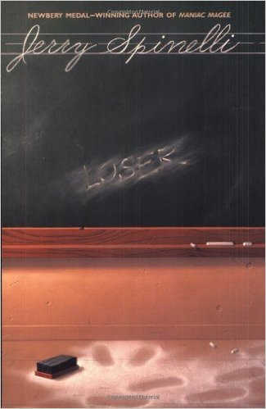
Dear Parents,

Because your child receives accommodations, they will have the option to read the novel that I just emailed you about OR they can work in a small group with Mr. M reading a different book. The other book touches on all the topics that meet the standards, it will just be a much easier book.

The book is "Loser" by Jerry Spinelli, and it is at a 4th grade reading level. Your child will take away just as much information, but on a modified level. The book is currently $6.99 on Amazon.

I NEED you to email me saying which book your child will be reading so I can make a list. I will send another letter home with them, when I send one about the other book.

If your family cannot afford to purchase this book, I completely understand. Growing up, my family often struggled with the same thing. I would like to make sure that all child have their own copy, so please email me and my fiancé and I will purchase a copy for your child.

Thank you,
Ms. Hodshon

Please return this slip by Friday, August 14th
Child’s Name: ____________________________________
Period: _________________

- I understand that my child will need a copy of this book on September 8th. This is the first day back from track-out.
- I approve of my child reading this novel and I do not object to the teaching of this book.
- Currently, my family cannot afford to purchase this book and I will need a copy of the book supplied to my child.
Parent Signature: _________________________________________________________

