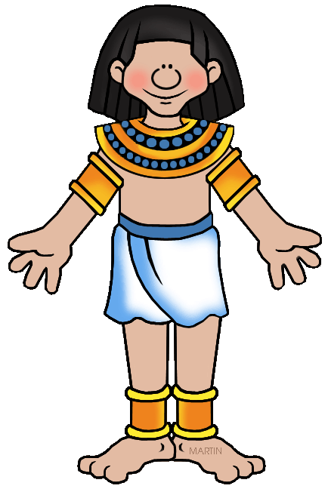
For your Egyptian unit SS project, you will be building your own 3D Egyptian pyramid! Each student will be required to design and decorate their pyramid to the theme of their choosing. Examples of different themes in the past have been a playing card themed pyramid, a golf themed pyramid and a reading pyramid. This is a chance for you to think outside the box and be creative!
Each student must design and build a pyramid that is no smaller than 1 foot wide and 1 foot tall, but no larger than 3 feet wide and 4 feet tall. Your pyramid must have the following included, or points will be taken away if the components are missing:
- The pyramid must open so that we can see the inside. You have the choice of having a side open or a 3 sided pyramid.
- You must create a theme for your pyramid and the pharaoh that designed the pyramid.
- You must have items that the pharaoh was buried with.
- You must have a sarcophagus and other items buried with the pharaoh.
- You are required to write a short story explaining who your pharaoh was, what they enjoyed, how they behaved and why the selected the theme that they did for their pyramid. This is a creative writing piece, assistance will be given during SMART Block. This story must be 3 paragraphs and typed/written in black ink.

Your project will be due on: October 16, 2015. This assignment is a major assessment and will be added into the gradebook as a test grade!

Requirement | 4 points | 3 points | 2 points | 1 point | 0 points
The student designs a pyramid with a theme that fits the story that they have constructed about the life of their fake pharaoh. The pyramid must have one removable/nonexistent side, so viewers can see inside. (C.1.1/C.1.2) | Pyramid has a consistent theme throughout the project. It is 3D and meets the height requirements. The pyramid has a removable side or is only 3 sided so that people can see in. | Pyramid has a consistent theme throughout the project. It is 3D but doesn’t meet the height requirements. The pyramid has a removable side or is only 3 sided so that people can see in. | Pyramid theme is scattered and not well maintained throughout the project. There is a small door or window to see the inside of the pyramid, but a viewer cannot see the entire inside of the pyramid. | Theme is scattered and not maintained, the height requirements were not met. There is a small door or window to see the inside of the pyramid, but a viewer cannot see the entire inside of the pyramid. | There is no theme to the pyramid. There is no way to see inside of the pyramid. Only the exterior is decorated.
There is a sarcophagus and objects that the pharaoh would have been buried with.  (C.1.1) | The student has built a sarcophagus and added at least 3 other items to the pyramid that add to the overall theme of the project and story. | The student has built a sarcophagus and added at least 2 other items to the pyramid that add to the overall theme of the project and story. | The student has built a sarcophagus and added 1 other items to the pyramid that add to the overall theme of the project and story. | There is no sarcophagus, but other objects have been added to the interior of the pyramid. | There is no sarcophagus or additional items added to the interior of the pyramid.
There is a 3 paragraph story explaining the tale of the pharaoh and the pyramid that they built.  (W.6.4) | The student has 3 well written paragraphs that tell the story of who the pharaoh is and why they wanted their pyramid designed the way that they did. | The student has a well written story that tell the story of who the pharaoh is and why they wanted their pyramid designed the way that they did. It is less than 3 paragraphs. | The student wrote 3 paragraphs but it does not explain the theme of the pyramid or who the pharaoh was as a person. | The story is less than 3 paragraphs and does not explain the theme of the pyramid or who the pharaoh was as a person. | The student did not write a story explaining the theme.
The work is organized, there are no spelling mistakes, and it is the student’s best work.  (W.6.5) | There are no spelling or grammar mistakes. | There are 1-3 spelling or grammar mistakes. | There are 4-7 spelling or grammar mistakes. | There are 8-10 spelling or grammar mistakes. | There are more than 10 spelling or grammar mistakes.
Student’s writing and pyramid shows evidence of the understanding of the impact that religion had on pyramid design. (C.1.2) | The student’s project shows complete understanding of the large impact that religion had on the design and creation of the pyramids. |  | The student’s project shows mediocre understanding of the large impact that religion had on the design and creation of the pyramids. | The student’s project shows limited understanding of the large impact that religion had on the design and creation of the pyramids. | The student’s project shows no understanding of the large impact that religion had on the design and creation of the pyramids.
Student’s writing and pyramid shows evidence of the understanding of the impact social class ranking had on Egyptian citizens and the creation of the pyramids. (C&G 1.2) | The student’s project shows complete understanding of the large impact that social class ranking had on Egyptian citizens and the creation of the pyramids. |  | The student’s project shows mediocre understanding of the large impact that social class ranking had on Egyptian citizens and the creation of the pyramids. | The student’s project shows limited understanding of the large impact that social class ranking had on Egyptian citizens and the creation of the pyramids. | The student’s project shows no understanding of the large impact that social class ranking had on Egyptian citizens and the creation of the pyramids.

