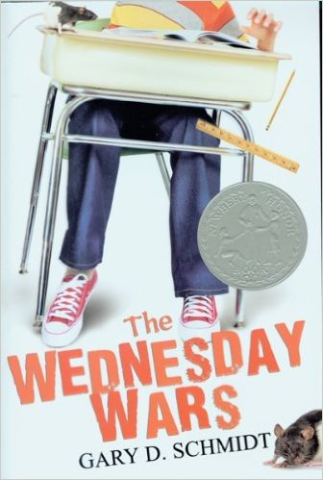
Dear Parents,

First of all, please let me say that I am so fortunate to have such an amazingly supportive group of parents this year. You have made me feel welcomed and made my experience at WLMS that much greater.

I am SUPER excited to announce that I have selected our first novel study for the year!!! Students will be reading "The Wednesday Wars" by Gary D. Schmidt and we will be studying it as a whole class. This book is one that I will be able to use as an "anchor" for all of the other units that we will explore this year. This is a book that based off standards is a 6.2 reading level book, and I think it will challenge a lot of our students to see that there are entertaining books that can still push them on an academic level.

Students will need this book by September 8th. That is the day that they track back in, and they will be using it in class. I AM BEGGING you to please do not let them have it/read it, until we study it as a class. Book studies tend to get ruined when kids read ahead :)

It is only $6.30 on Amazon, so that may be the best deal :)

If your family cannot afford to purchase this book, I completely understand. Growing up, my family often struggled with the same thing. I would like to make sure that all child have their own copy, so please email me and my fiancé and I will purchase a copy for your child.

Thank you,
Ms. Hodshon

Please return this slip by Friday, August 14th
Child’s Name: ____________________________________
Period: _________________

- I understand that my child will need a copy of this book on September 8th. This is the first day back from track-out.
- I approve of my child reading this novel and I do not object to the teaching of this book.
- Currently, my family cannot afford to purchase this book and I will need a copy of the book supplied to my child.
Parent Signature: _________________________________________________________

